Ignasi Arranz, Bertrand Fournier, Nigel P. Lester, Brian J. Shuter, and Pedro R. Peres-Neto. Species compositions mediate biomass conservation: the case of lake fish communities. Ecology.

Appendix S5. Estimating slope of the biomass size spectrum

To estimate the size spectrum slope, we first described the size frequency of fish in each lake (Table S1; Fig. S1; Fig. S2). BPUE within each size class represents the expected catch from fishing 100 m of each net for 18 h. It is a biased index of fish density because gillnet sampling is size selective: (*i*) mesh size affects the size of fish captured, and (*ii*) larger fish are more likely to encounter the gear given that swimming speed and home range increase with body size (Rudstam et al. 1984). To correct for this bias, we estimated the size selectivity of our sampling method and then calculated corrected indices as BPUE.Selectivity-1 (Appendix S3: Fig. S1). These corrected indices of biomass, calculated for different size classes of fish, were used to estimate the slope of the Normalized BiomassSpectrum (NBS) (Fig. S3).

We also used maximum likelihood methods (MLE) to estimate slopes (Edwards et al. 2017) but we found the two methods were highly correlated (Pearson’s rank correlation r=0.88; Appendix S5: Fig. S4). We used the OLS slopes in subsequent analyses because Xiao et al. (2011) showed that OLS on binned data works best under the multiplicative error structure that almost certainly holds for our data.

References

Edwards, A. M. et al. 2017. Testing and recommending methods for fitting size spectra to data. Methods in Ecology and Evolution **8**: 57–67.

Rudstam, L. G., J. J. Magnuson, and W. M. Tonn. 1984. Size selectivity of passive angling gear: a correction for encounter probability applied to gill nets. Canadian Journal of Fisheries and Aquatic Sciences **41**: 1252–1255.

Xiao, X., E. P. White, M. B. Hooten, and S. L. Durham. 2011. On the use of log-transformation vs. nonlinear regression for analyzing biological power laws. Ecology **92**: 1887–1894.

**Table S1.** Table showing the mean fish size distribution for the entire dataset (639 lakes). Mean BPUE is shown for a geometric series of size intervals (0–2 g, 2–4 g, 4–8 g, 8–16 g, etc) along with estimates of the sampling selectivity (see Appendix S3). Corrected BPUE is calculated as BPUE divided by Selectivity. This index of biomass density is used to calculate a normalized index of biomass density (= Corrected BPUE divided by widthof the size interval). Regressing the logarithm of this index against the size interval label (i.e., log2(body mass)) supplies an estimate of the size spectrum slope, as illustrated in Fig. S1 of Appendix S5.

|  |  |  |  |  |  |  |  |  |  |
| --- | --- | --- | --- | --- | --- | --- | --- | --- | --- |
| **Size Interval** | **Body mass (g)** | **Interval Width** | | **Size Range (g)** | **Proportion of lakes** | **BPUE** | **Selectivity** | **Corrected BPUE** | **Normalized Corrected BPUE** |
| *1 | 2 | 2 | 2–4 | | 0.97 | 0.08 | 0.006 | 13.34 | 6.6699 |
| 2 | 4 | 4 | 4–8 | | 0.99 | 0.20 | 0.016 | 12.07 | 3.0165 |
| 3 | 8 | 8 | 8–16 | | 1.00 | 0.41 | 0.034 | 12.08 | 1.5099 |
| 4 | 16 | 16 | 16–32 | | 1.00 | 0.57 | 0.072 | 7.92 | 0.4953 |
| 5 | 32 | 32 | 32–64 | | 1.00 | 0.90 | 0.136 | 6.61 | 0.2065 |
| 6 | 64 | 64 | 64–128 | | 1.00 | 1.33 | 0.227 | 5.84 | 0.0913 |
| 7 | 128 | 128 | 128–256 | | 0.99 | 1.46 | 0.257 | 5.68 | 0.0444 |
| 8 | 256 | 256 | 256–512 | | 0.99 | 2.90 | 0.407 | 7.13 | 0.0278 |
| 9 | 512 | 512 | 512–1024 | | 1.00 | 7.27 | 0.582 | 12.49 | 0.0244 |
| 10 | 1,024 | 1,024 | 1,024–2,048 | | 0.98 | 9.66 | 0.794 | 12.17 | 0.0119 |
| 11 | 2,048 | 2,048 | 2,048–4,096 | | 0.86 | 3.71 | 0.940 | 3.94 | 0.0019 |
| *12 | 4,096 | 4,096 | 4,096–8,192 | | 0.39 | 1.73 | 0.691 | 2.50 | 0.0006 |
| *13 | 8,192 | 8,192 | 8,192–16,384 | | 0.04 | 1.84 | 0.771 | 2.39 | 0.0003 |



**Figure S1.** Demonstration of how the slope of the Normalized Biomass Size Spectrum slope estimated by regression. This example uses the data from Table S1 of Appendix S5. The slope was estimated for log2(Body mass) between 2 and 11 size classes (i.e., a mass ranges from 4 to 4,096 g), a size range that existed in most lakes (i.e., over 98% of lakes contained fish in each size interval from 2 to 10 and 86% in 11). Larger size bins were excluded because fish larger than 4,096 g were caught in relatively few lakes (i.e., 39%).

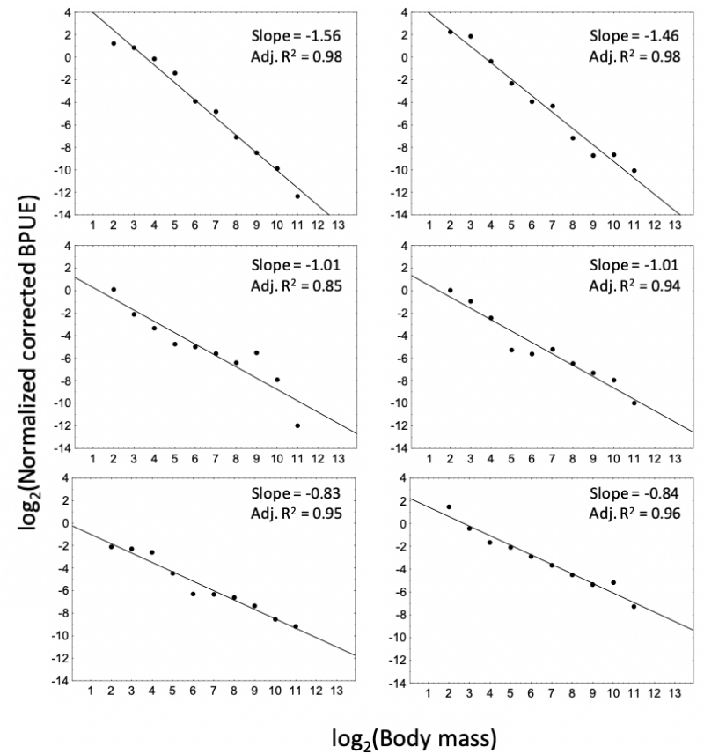

**Figure S2**. Examples of biomass-size distributions for six lakes. The normalized corrected BPUE (expressed in log2 units) is plotted against log2(body mass). Ordinary least squares (OLS) regression was done to estimate the slope.



**Figure S3.** Statisticalinformation related to the OLS estimates of the slope of the Normalized Biomass Spectrum for 639 lakes: (a) standard error of the slope versus estimated slope; (b) boxplot showing that the mean slope matches the theoretical expectation of slope = -1; (c) frequency distribution of the coefficient of determination (i.e., adjusted R2) from the regression analysis of each lake.



**Figure S4.** Comparison of size spectrum slopes estimated by a Maximum likelihood method (MLE) and ordinary least squares (OLS). MLE slopes were calculated from the binned data but using a bounded method to fit the observations following Edwards et al. (2017).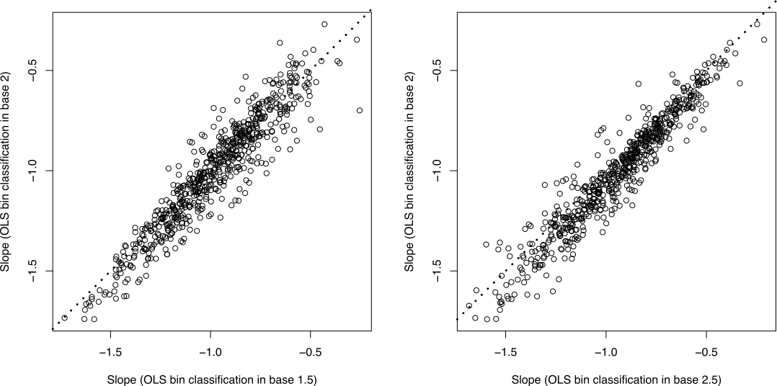

**Figure S5**. Comparison of the estimated OLS slopes using different bin classifications (i.e., in base 1.5 and 2.5). The y-axes show the OLS slopes with the used bin classification for the main analysis whereas the x-axes correspond to the OLS slopes when the number of size bins are increased (in base 1.5; left plot) and decreased (in base 2.5; right plot).